Maximize your time at the Iowa Business Analyst Development Day 2023 with the TBM Engage mobile app. Easily view the Schedule, Speakers, Instant Alerts and more! You can even create personalized lists to target what you want to see, hear & do.

Access the Iowa Business Analyst Development Day 2023 by downloading the TBM Engage app by entering the below URL into your device's browser:
http://www.tripbuildermedia.com/apps/tbmengage
This link will automatically detect your phone type and take you to the right place to download the app on the Apple App Store or Google Play Store. Or, just scan this QR Code & download the app now!
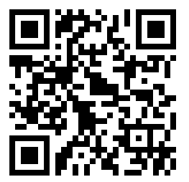
Once you have downloaded the TBM Engage app, enter in the Iowa Business Analyst Development Day 2023 app code: ibadd2023

Click on the Iowa Business Analyst Development Day 2023 to be taken to the event's login screen.
On the login screen, enter your username to enter into the event.

